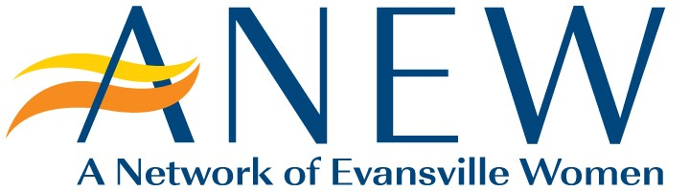**2025 Membership Application**

For over 40 years, A Network of Evansville Women (ANEW) has created countless opportunities for Evansville-area professional women to make connections that inspire personal and professional growth. Thank you for your interest in joining our network. Please complete the following membership application and a representative will be in touch soon with the next steps.

WHO ARE WE

We are the female leaders at the forefront of Evansville’s business, professional, cultural, nonprofit, and educational communities.

OUR PURPOSE

Our purpose is to connect with each other for personal and professional growth, advance our community through civic, business, and philanthropic initiatives, and inspire the next generation of female leaders in our community.

Name: _______________________________________________________________________________  
 (First) (last)

Email*: _______________________________________________________________________________

Phone Number: _____(_____)____________________________________________________________

Please attach an updated resume. (Resume should include education/certifications and community service leadership/work.)

Please attach an updated bio. (Bio should also showcase any community service, current board leadership, etc.)

How did you hear about ANEW? ___________________________________________________________________________________________

___________________________________________________________________________________________

___________________________________________________________________________________________

___________________________________________________________________________________________

Why are you interested in joining ANEW? What do you want to get out of this opportunity? (Personally and/or professionally)

_________________________________________________________________________________________

_________________________________________________________________________________________

_________________________________________________________________________________________

_________________________________________________________________________________________

What do you believe you can bring to enhance our networking group?

_________________________________________________________________________________________

_________________________________________________________________________________________

_________________________________________________________________________________________

_________________________________________________________________________________________

Do you have an ANEW sponsor or are you connected with a member of ANEW?

Current ANEW Member Name: ________________________________________

Name of ANEW Member/Sponsor: _______________________________________________